Proof of Concept (POC) of Sprint-1:

Project: AI-Powered Language Learning Platform (Fluentify)

Sprint Goal: Design and implement the initial framework by developing the user interface, database schema, and authentication workflow (with validation and role-based access), along with a prototype dashboard to support learner onboarding and preferences.

Sprint Objective:

To implement the core authentication and onboarding workflow for the platform covering both frontend and backend components:

Responsive Sign-Up and Login UI for learners and admins.

Secure backend APIs for authentication and preferences.

Password encryption with bcrypt and JWT-based session management.

Database schema setup with learners, admins, and preferences tables.

Prototype dashboard accessible upon successful login.

Features Completed:

1.Frontend Development

Sign-Up Page:

Email validation to block fake entries.

Strong password policy (minimum length of 8).

Login Page:

Credential validation.

Redirection to dashboard upon successful authentication.

Dashboard (Prototype):

Provides entry point for learners/admins post-login and includes placeholders for various modules.

Routing & State Handling:

React Router DOM configured for protected routes.

Session management with JWT decode.

Styling & Standards:

TailwindCSS for responsive UI

ESLint for code quality

2.Backend Development

Database Setup

Tables Created:

learners (unique email constraint, timestamps).

admins (secure storage with hashed passwords).

learner_preferences (language + expected duration).

Migration Scripts:

Create_tables.sql

Create_learn_preferences.sql

Authentication APIs (/api/auth)

Learner Signup (POST /signup/learner): stores learner details with encrypted password.

Returns JWT with role = learner.

Admin Signup (POST /signup/admin): stores admin details securely.

Returns JWT with role = admin.

Learner Login (POST /login/learner): validates credentials, checks preferences.

Returns JWT + hasPreferences flag.

Admin Login (POST /login/admin): validates credentials.

Returns JWT with admin role.

Profile (Protected) (GET /profile): validates JWT and returns user details.

Preferences APIs (/api/preferences)

Set Preferences (POST /learner): learners store language + duration.

Get Preferences (GET /learner): fetch learner preferences.

Role-based access enforced (learners only).

Middleware & Helpers

authMiddleware.js: JWT verification and role extraction.

db.js: centralized query helper for Postgres.

Server Setup

server.js: Express with CORS + JSON parsing.

Health Check Routes:

/: backend status.

/db-check: verifies DB connection.

3.Security Implementations

Passwords hashed with bcrypt before storage.

JWT signed with process.env.JWT_SECRET, expiring in 2 hours.

Role-based access control (learner vs admin).

Protected routes require Authorization: Bearer header.

4.Testing & Verification

Frontend:

Form validation tested (invalid email, weak passwords rejected).

Login → Dashboard flow verified.

Backend:

/db-check confirms DB connection.

Postman/Thunder Client tested all endpoints.

Unauthorized access attempts returned correct 401/403 errors.

UI Research: Conducted analysis on existing language learning platforms to identify strengths and weaknesses, and decided on UI structure and navigation flow aiming for a scalable and user-oriented interface.

Database Creation: Created initial database comprising of admin, users (user credentials, authentication data), and learner preferences (proficiency levels, learning objectives, language preference) using DBMS principles to ensure data integrity and security.

User Authentication & Validation:

Sign-up process: Features strict validation including strong password policy and email verification to prevent fake registrations.

Login process: Authenticates users against hashed credentials and establishes a secure, persistent session to prevent unauthorized access to the user dashboard.

Dashboard Implementation: Upon successful login, users are directed to the dashboard which currently functions as a prototype interface, incorporating placeholders for forthcoming features like AI conversational tutor, progress analytics, and cultural-context modules.

Time Duration: Two weeks

Week 1 → Research + UI wireframe + Database design

Week 2 → Authentication module + Dashboard prototype + Documentation

Sprint-1 Deliverables:

UI wireframe

Database schema

Authentication system (sign-up, login, validation)

Dashboard Prototype

Documentation

Sprint 1 Outcome:

Objectives were successfully implemented.

The platform now supports:

Secure sign-up and login for learners and admins.

Database-backed authentication with encrypted credentials.

Preferences storage and retrieval.

A prototype dashboard with navigation flow.

This Sprint establishes the baseline system architecture for upcoming sprints, including AI tutor integration, admin dashboards, and advanced learner progress tracking.

Sprint 1 Status: Completed

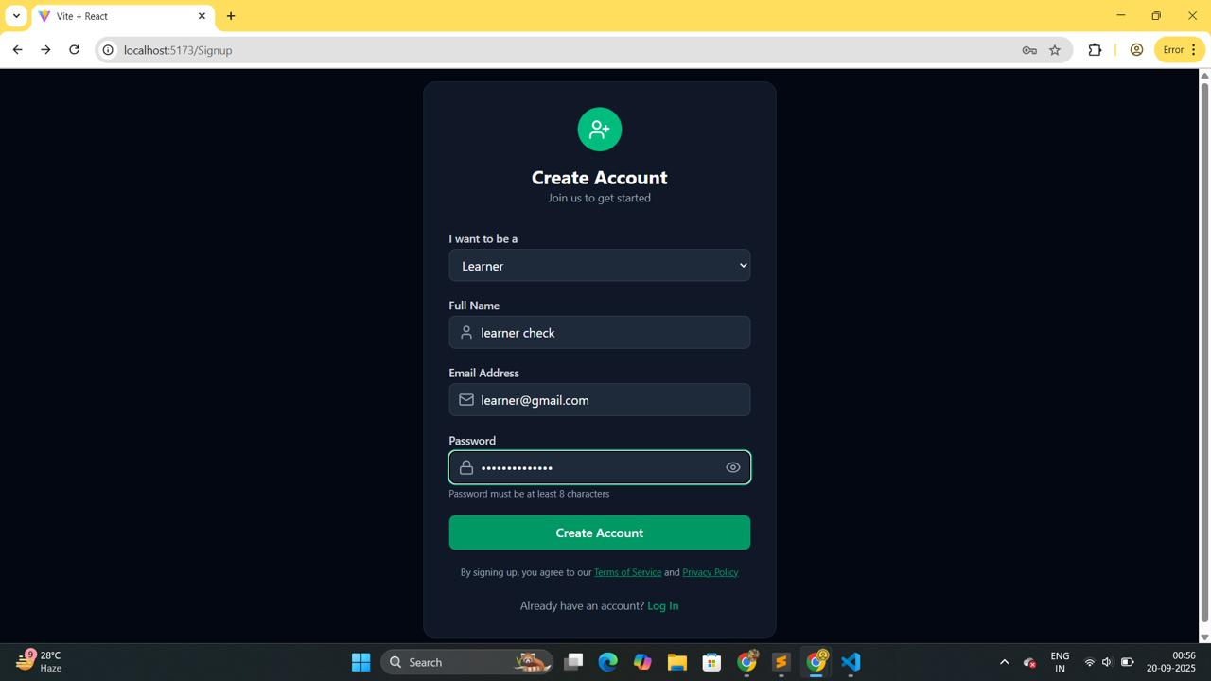

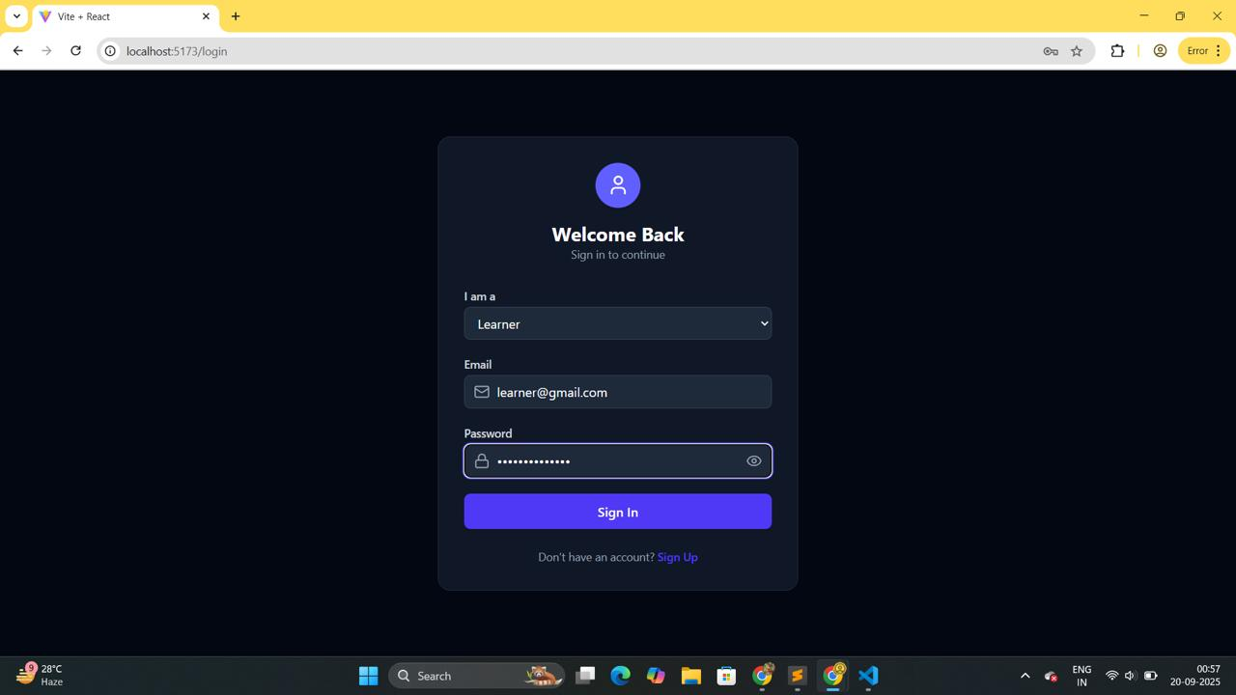

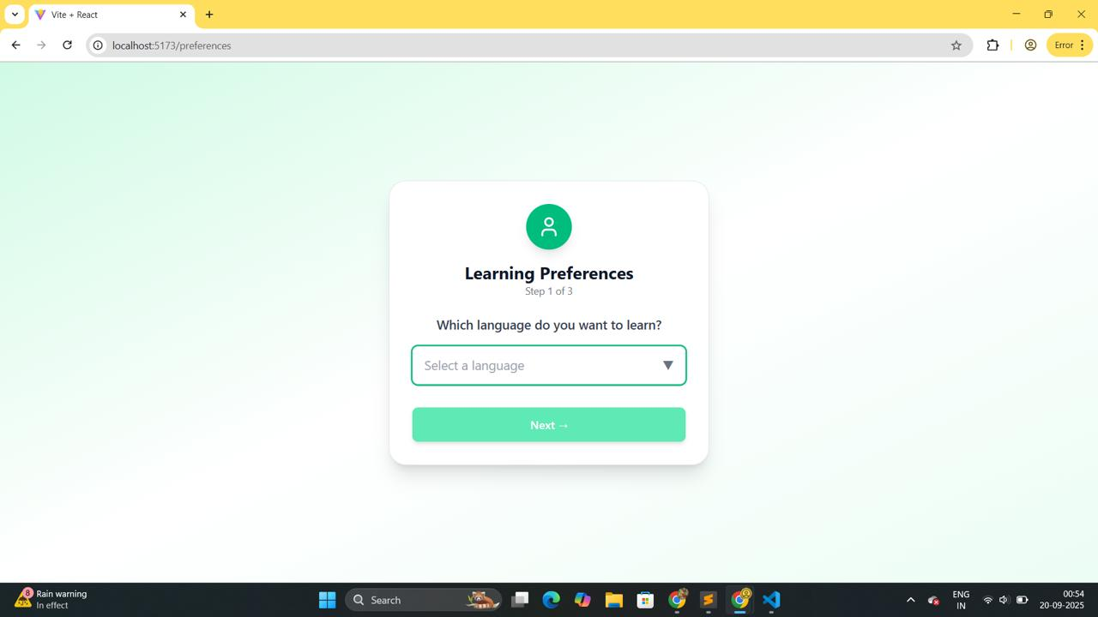

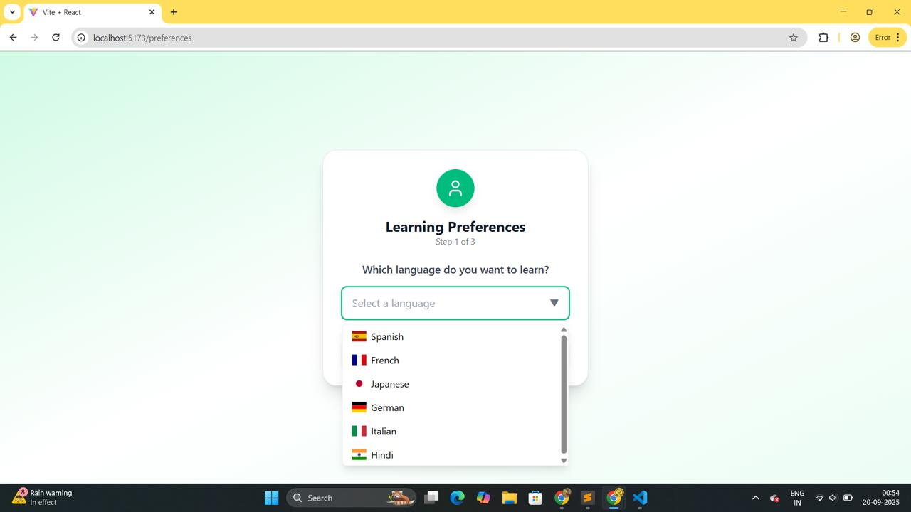

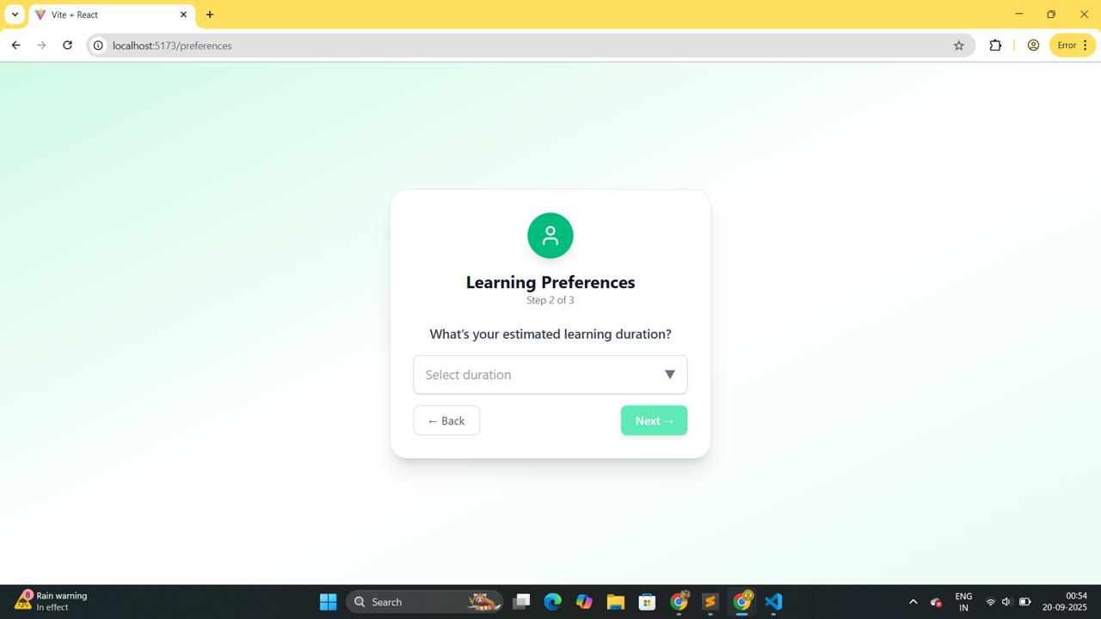

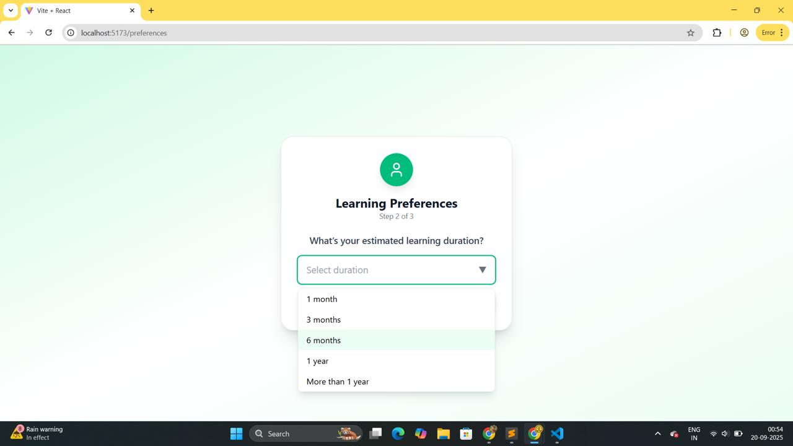
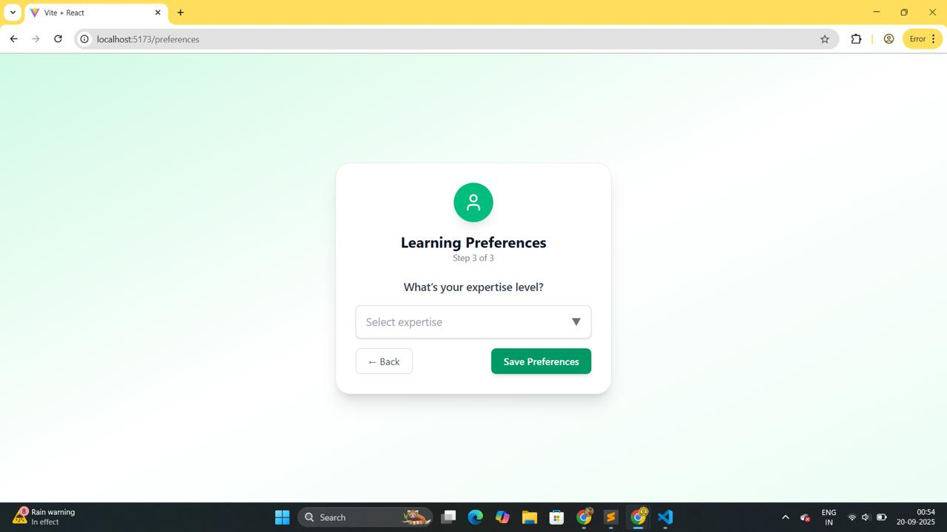

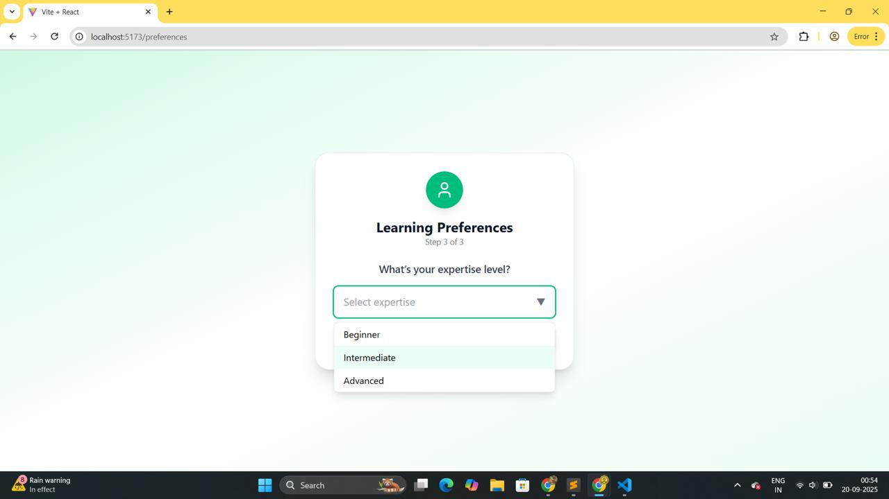

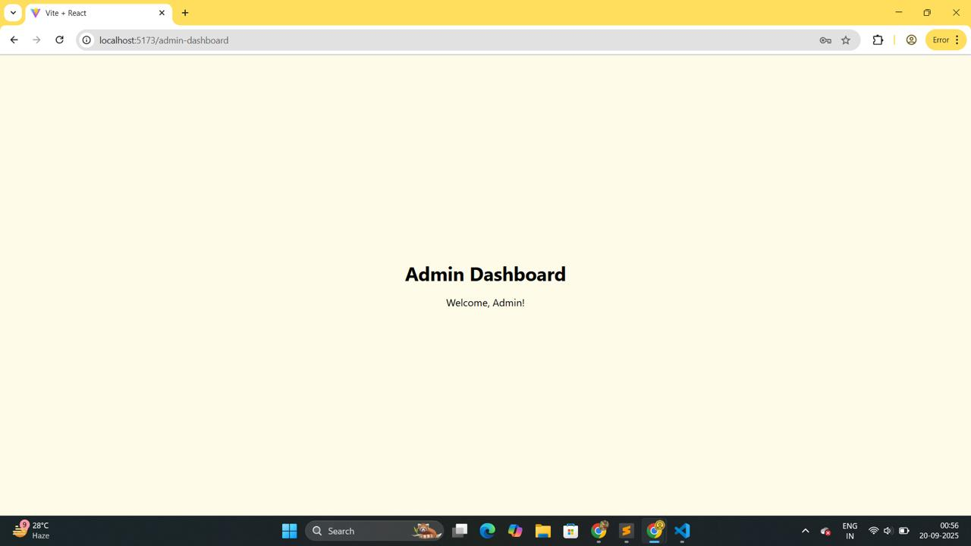

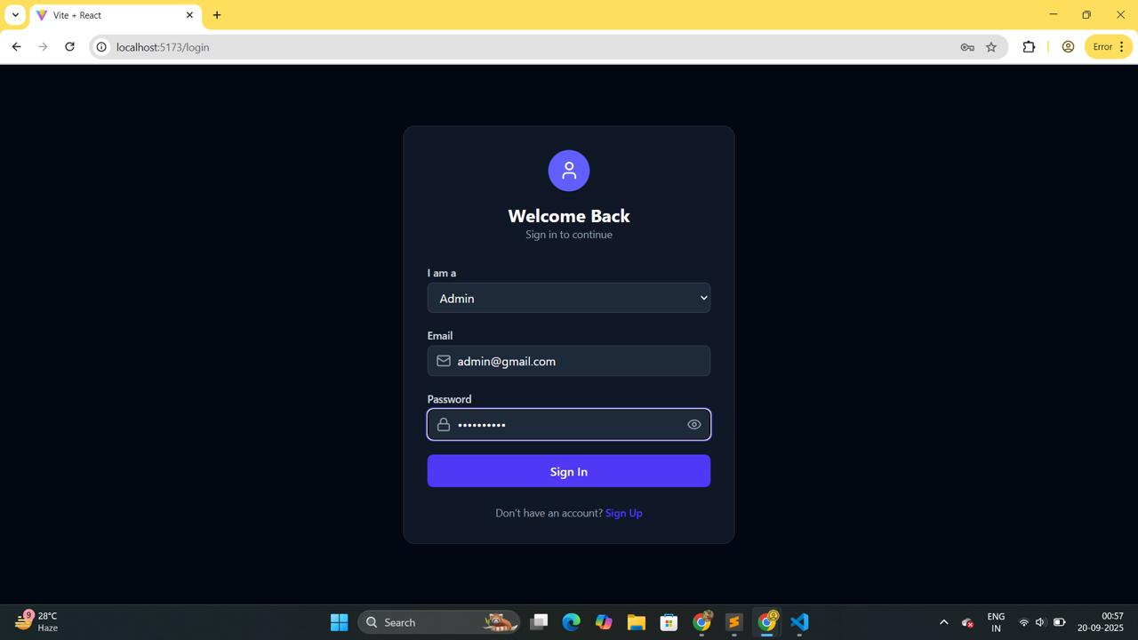

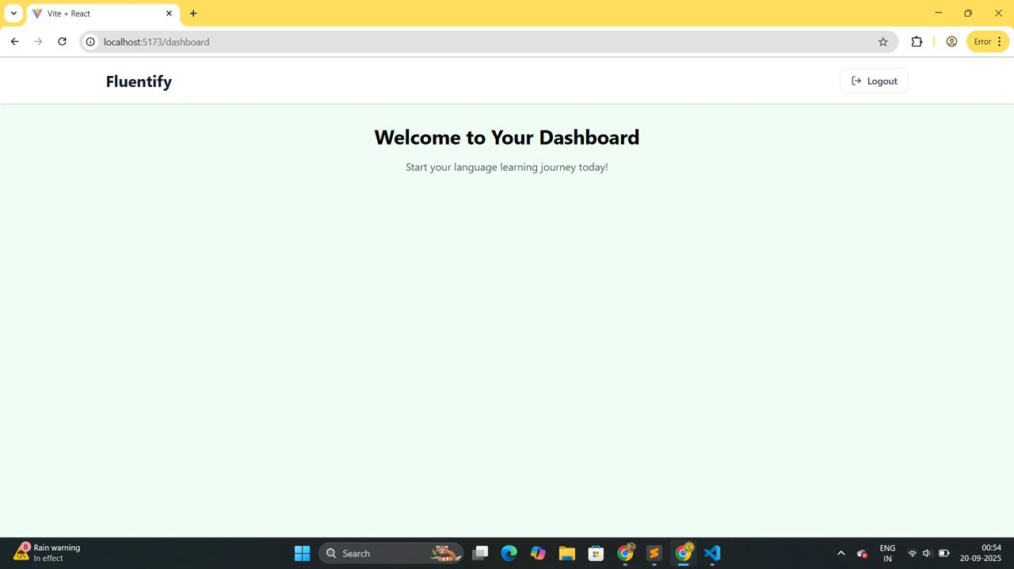

These outputs collectively confirm that Sprint-1 deliverables - authentication system, and prototype dashboard were successfully implemented and tested.

